***Lyddie***

***Chapter 2-  Kindly Friends***

***Summary:***

In Chapter 2, [Lyddie](https://www.enotes.com/topics/lyddie?en_action=hh_answer_body_click&en_label=%2Fhomework-help%2Fwhat-summary-chapter-2-lyddie-285721%23answer-776503&en_category=internal_campaign) and Charles leave their home and go separate ways. Each of them has been hired out to work in order to pay off debts their mother owes on their property. The land has been rented to a neighbor, Mr. Westcott, to farm, and he is to have their horse and cow as well. Lyddie and Charles close up their cabin, piling logs in front of the door to prevent a return of the bear. They discuss what to do with their calf. In their mother's absence, they had bred the cow, and their mother doesn't know about the calf, so she didn't promise it to Mr. Westcott.

As they near the farm next to theirs, which belongs to the Stevens family, the neighbor greets them. When he finds out what has happened to their family, he's filled with compassion for the two young people, which embarrasses them. He purchases the calf from them, at a generous price, and invites them to dinner. Luke Stevens, one of the sons, offers to give the two a ride to their respective workplaces. Lyddie is cool and even rude to him, brushing off his offers to help them.

Luke stops at the mill to drop Charles off, and Lyddie parts from him, nearly crying. Luke then drops her off at the tavern where she will be working. He offers to go in with her, but she refuses because she doesn't want to be seen with a Quaker. Luke is not offended by Lyddie's poor manners; he continues to be kind. He promises to keep an eye on their house and to look in on Charles.

In chapter 2, Lyddie and Charles, her brother, meet the new farmer’s son, Luke.  Luke’s family is renting the farm because Lyddie encountered a bear and her mother no longer thinks the farm is safe.  In this chapter, Luke drives Charles and Lyddie to their new jobs in his horse and buggy.  Charles goes to work at Baker’s Mill and Lyddie will work as a maid at Cutler’s Tavern.

As chapter 2 opens, [Lyddie](https://www.enotes.com/topics/lyddie?en_action=hh_answer_body_click&en_label=%2Fhomework-help%2Fwhat-happens-chapter-2-lyddie-573983%23answer-751119&en_category=internal_campaign) and Charlie have received word from their mother that they have been hired out to pay off the family's debts. They make their preparations to leave, and they both arrive at their separate destinations: Charlie at the mill and Lyddie at the tavern. As they are getting ready to leave, they discuss the fact that the calf that has been born since their mother left belongs to them, so they decide to sell it and keep the money as "seed money" to start up farming again once the debts are paid and they can return. They then clean out the cabin and stack wood in front of the door to keep animals out. As they walk toward their destinations, they come to the Stevenses' farm. Mr. Stevens purchases their calf for $25 and invites them to dinner. Then Luke Stevens gives them a ride in his wagon so they don't have to walk the rest of the way. The Stevenses are Quakers, also known as Friends, which is why the chapter is called "Kindly Friends." The Stevenses treat the children with kindness and are sympathetic to their plight. Charlie returns their friendship easily, but Lyddie keeps them at arm's length. Like her mother, she is suspicious of the neighbors for being Quakers, and she feels awkward around Luke, who wears a "funny black hat."

***Summary in Detail:***

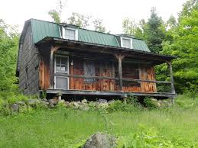

As Lyddie and Charlie began to pack their belongings to leave their farm they felt very sad.

Lyddie said to Charlie, "She didn't say nothing about the calf"

"she got no cause to" Charles said, "we never tell her about it"

"You know, Charlie, the calf is rightfully ours"

As they continued their conversation, Lyddie and Charlie decided that because Mama was selling them away to work to pay off the family [debts](http://bookbuilder.cast.org/view_glossary.php?book=109974&word=85074#curr) , they did not owe her the [calf](http://bookbuilder.cast.org/view_glossary.php?book=109974&word=85075#curr)  which was worth some money.

Lyddie tells Charlie that they need to sell the calf and hide the money to help them take care of the farm when papa comes back one day.

Charlie said, "maybe Mama'll sell the farm"

"She can't, not so long as Papa is alive" said Lyddie.

Lyddie and Charlie continued to think about when and if Papa would ever come home.

They began to clean the cabin together.  They swept out the splintery plank floor and took good care of it even though it was not as nice as the other farmhouses along the road.

Lyddie knew that their cabin had been built by Papa and that every year Papa had promised that he would make more money and sell their crops to make the farm and house bigger and more proper.

However, even though Papa made promises, he [borrowed](http://bookbuilder.cast.org/view_glossary.php?book=109974&word=85076#curr) money from the bank to pay for new [crops](http://bookbuilder.cast.org/view_glossary.php?book=109974&word=85077#curr) and when his cotton crops [failed to sell](http://bookbuilder.cast.org/view_glossary.php?book=109974&word=85078#curr) when the [market](http://bookbuilder.cast.org/view_glossary.php?book=109974&word=85079#curr)  [collapsed](http://bookbuilder.cast.org/view_glossary.php?book=109974&word=85080#curr) he owed the bank a lot of money.  This was how the family fell into debt. Papa had always been an unlucky man.

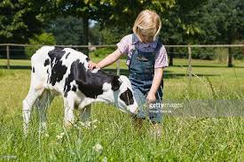

As Lyddie and Charlie finished packing up to leave they began worrying about the bear and how they could keep the wild animals out of the house while they were gone. Finally, Charles suggested that they take all the wood left in the woodpile and stack it in front of the door.

Lyddie and Charles began their journey by walking to Quaker Stevens' Farm.  Charles rode on their horse while Lyddie walked closely behind with the calf and mother cow.

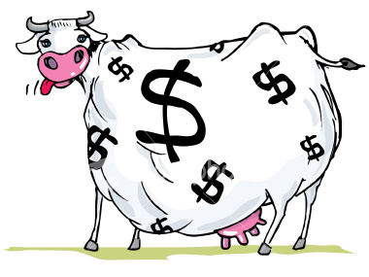

Soon Lyddie and Charles could see [Quaker](http://bookbuilder.cast.org/view_glossary.php?book=109974&word=85081#curr) Stevens waving to them in the distance.  Lyddie knew that a quaker was someone who was supposed to live very simply, but she also knew the Stevens' were too rich to live that simply.  Their farm was much bigger and nicer than Lyddie's was.

Lyddie said to Quaker Stevens "we come to thank you" and she thought for a minute before she continued and said "The truth is we're taking the horse and cow to Mr. Wescott- in payment of [debt](http://bookbuilder.cast.org/view_glossary.php?book=109974&word=85082#curr)  and we're [obliged](http://bookbuilder.cast.org/view_glossary.php?book=109974&word=85083#curr)  to sell off this pretty calf straight away.  Our mother's put us off to work"

"[Thee](http://bookbuilder.cast.org/view_glossary.php?book=109974&word=85084#curr) 's leaving thy land? Thee's been alone all winter, just thee two children?" Quaker stevens asked.

He couldn't believe that Lyddie and Charles had survived alone for the entire winter.  Lyddie then waited to see if Quaker Stevens would buy their calf.

He said, "I'll give thee twenty dollars for the calf" "No, twenty five. I know the [sire](http://bookbuilder.cast.org/view_glossary.php?book=109974&word=85085#curr) and [he's of a good line](http://bookbuilder.cast.org/view_glossary.php?book=109974&word=85086#curr) ".

Lyddie knew that the calf was half Quaker Stevens' anyway because they had used his [bull](http://bookbuilder.cast.org/view_glossary.php?book=109974&word=85087#curr) to [breed](http://bookbuilder.cast.org/view_glossary.php?book=109974&word=85088#curr)  the calf.  But, she also knew they needed the money.  Lyddie agreed to the deal.

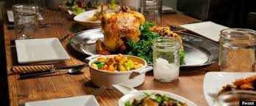

After Lyddie sold the cow back to Quaker Stevens he invited Lyddie and Charles in for a nice lunch. As soon as Lyddie went into their house the Quaker's were rich because they had their own [loom](http://bookbuilder.cast.org/view_glossary.php?book=109974&word=85089#curr) and the meal was spread out on a long[oak](http://bookbuilder.cast.org/view_glossary.php?book=109974&word=85090#curr) table which looked like a king's feast to Lyddie and Charles who had lived mostly on rabbit and bark soup all winter.

While they ate, Quaker Stevens offered Lyddie and Charles a ride to the mill and then the village if they wanted.  Lyddie and Charles agreed.

After the meal, Luke Stevens, Quaker Stevens' son, Quaker Stevens, Charles, and Lyddie got into the coach in order to head to the mill and then the village.  Luke Stevens tried to help Lyddie into the coach, but she did not want to seem like a helpless child or a helpless female so she ignored him and got in by herself.

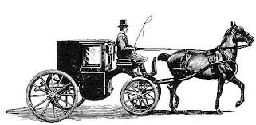

As Lyddie sat in the [carriage](http://bookbuilder.cast.org/view_glossary.php?book=109974&word=85091#curr) with Charles, Luke, and Quaker Stevens she thought about how lucky Luke Stevens was to have both a mother and a father while she felt like she had no one.

Luke then asked if Lyddie and Charles would like him to come and check on their farm while they were away to make sure everything was ok.

Lyddie did not want to accept help from Luke, but Charles agreed.

Then, the carriage pulled up to the mill where Charles was going to be dropped off.  Charles put his little hand on Lyddie's arm and said "You mustn't worry ey Lyddie, you'll be all right"

Lyddie almost laughed.  He was trying to [comfort](http://bookbuilder.cast.org/view_glossary.php?book=109974&word=85092#curr)  her.  Or maybe she nearly cried.  She watched as Charles walked away into the [distance](http://bookbuilder.cast.org/view_glossary.php?book=109974&word=85093#curr) .  He waved to her, and then disappeared.

A few hours later....

Luke said "This here is Cutler's Tavern" They hadn't spoken since they had left Charles at the mill.  "[Shall](http://bookbuilder.cast.org/view_glossary.php?book=109974&word=85094#curr) I come to the door with [thee](http://bookbuilder.cast.org/view_glossary.php?book=109974&word=85095#curr) ?" he asked.

Lyddie said "No, no need"

Luke said, "I hope to see thee before too much time is up, meantime I'll see to [thy](http://bookbuilder.cast.org/view_glossary.php?book=109974&word=85096#curr) house" then he leaned over the seat and said "I'll give a look in on thy Charlie too, he's a good boy"

Lyddie didn't know whether to be pleased or annoyed,  but he clicked his tongue and the wagon pulled away, leaving her alone in her new life.